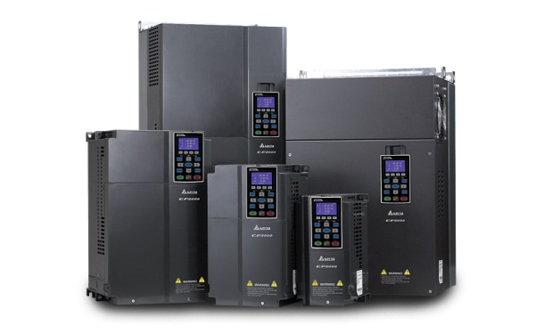
อินเวอร์เตอร์ เดลต้า รุ่น CP2000
Delta's Sensorless Vector Control Drive CP2000 Series has extended the idea of energy saving and uses this principal as the basis of its design. The CP2000 is specifically designed for applications such as air blowers, pumps and HVAC drives with its intelligent PID control providing the greatest efficiency. The Sensorless Vector Control (SVC) offers timely response to load torque increase/decrease which satisfies customer requirements for load changes while enhancing motor performance.
ประเภทสินค้า : INVERTER, อินเวอร์เตอร์
Series :VFD-CP2000 series
ลักษณะโครงสร้าง
Long-life design and self-diagnosis for key components.

Special PCB coating design (Printed Circuit Board) for enhancing environmental tolerance.

Complied with global safety standards: CE, UL and cUL

Standard LCD model (IP20/NEMA1) with built-in PLC to support up to 10K steps

Excellent heat-sink design. Able to operate at 50°C ambient temperature and to adjust automatically rated output value to make the AC drive to work continuously.

การใช้งาน
Fixed-displacement pumps (fix flow and fix time), building automation, factory automation,
HVAC drives, cooling pumps, cooling towers and general motor applications.

ขนาดที่มีให้ใช้ : 0.75kW – 400kW
ข้อมูลทางเทคนิค
With a built-in 10K steps Delta PLC allows user to execute distributional control and independent control when connecting to a network system. Delta CP2000 series drives provide you the intelligent control possibility beyond your imagination.

The calendar function allows user to program the PLC procedure, the ON/OFF in chronological order, the daylight saving time and etc.

Run fire mode while emergency to have uninterrupted smoke releasing and pressure adding

Multi pumps control at fixed amount, fixed time circulating control. Able to control 8 pumps at the same time.

