**อินเวอร์เตอร์ เดลต้า รุ่น CH2000**

**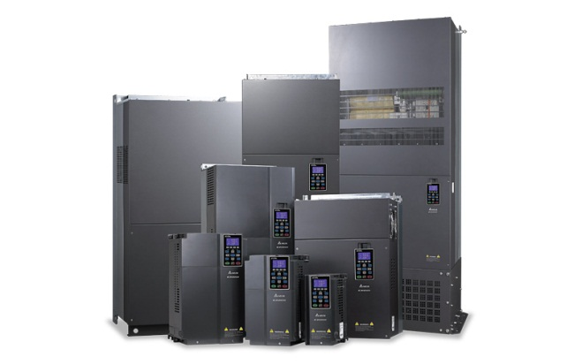***Using new drive technology, Delta presents you with its next generation CH2000 Series AC Motor Drive. Providing high performance with robust design the CH2000 is equipped with a larger starting torque and high overload capability to fulfill the needs of heavy load and impact loading applications.*

**ประเภทสินค้า : *INVERTER, อินเวอร์เตอร์***

**Series :VFD-CH2000 series**

**การใช้งาน**

*Crane, processing machinery, printing machinery*

**ขนาดที่มีให้ใช้ : 0.75kW – 280kW**

**ข้อมูลทางเทคนิค**

|  |
| --- |
|  |
|  | |  | | --- | |  | | *http://1-ps.googleusercontent.com/h/www.deltaww.com/fileCenter/ImagesNew/6x6xtab_dot.jpg.pagespeed.ic.xeawxs7j4A.jpg* | *Overload ability: rated current of 150% up to 60 seconds, 200% up to 3 seconds* | |  |  |  |  | | --- | |  | | *http://1-ps.googleusercontent.com/h/www.deltaww.com/fileCenter/ImagesNew/6x6xtab_dot.jpg.pagespeed.ic.xeawxs7j4A.jpg* | *Starting torque: above 200% at 0.5Hz in normal conditions, up to 200% at 0Hz in FOC+PG mode* | |  |  |  |  | | --- | |  | | *http://1-ps.googleusercontent.com/h/www.deltaww.com/fileCenter/ImagesNew/6x6xtab_dot.jpg.pagespeed.ic.xeawxs7j4A.jpg* | *Output frequency: 0.00~600.00Hz (for model above 90kW: 0.00~400Hz)* | |  |  |  |  | | --- | |  | | *http://1-ps.googleusercontent.com/h/www.deltaww.com/fileCenter/ImagesNew/6x6xtab_dot.jpg.pagespeed.ic.xeawxs7j4A.jpg* | *Induction motor and synchronous motor control* | |  |  |  |  | | --- | |  | | *http://1-ps.googleusercontent.com/h/www.deltaww.com/fileCenter/ImagesNew/6x6xtab_dot.jpg.pagespeed.ic.xeawxs7j4A.jpg* | *Built-in PLC program capacity: 10K steps* | |  |  |  |  | | --- | |  | | *http://1-ps.googleusercontent.com/h/www.deltaww.com/fileCenter/ImagesNew/6x6xtab_dot.jpg.pagespeed.ic.xeawxs7j4A.jpg* | *Noise reduction* | |

|  |
| --- |
|  |